### Emily Thorne's Child Diary

#### Diary Entry 1

**Date:** June 5, 20XX

Dear Diary,

Today was so much fun! Samuel and I went down to the lake near Grandma’s house. We played on the shore and skipped stones across the water. Samuel is really good at it! He made the stone bounce five times. I could only get three, but he said I did great. We found some really pretty shells and a little frog. I wanted to take it home, but Samuel said it needed to stay with its family.

Love,
Emily

---

#### Diary Entry 2

**Date:** June 12, 20XX

Dear Diary,

Samuel and I went exploring in the woods today. We pretended we were pirates looking for treasure. Samuel drew a map, and we followed it all the way to the big oak tree. We didn’t find any gold, but we found a cool bug with shiny wings. Samuel said it was a dragonfly. We also made up a secret handshake that only we know. It was the best day ever!

Love,
Emily

---

#### Diary Entry 3
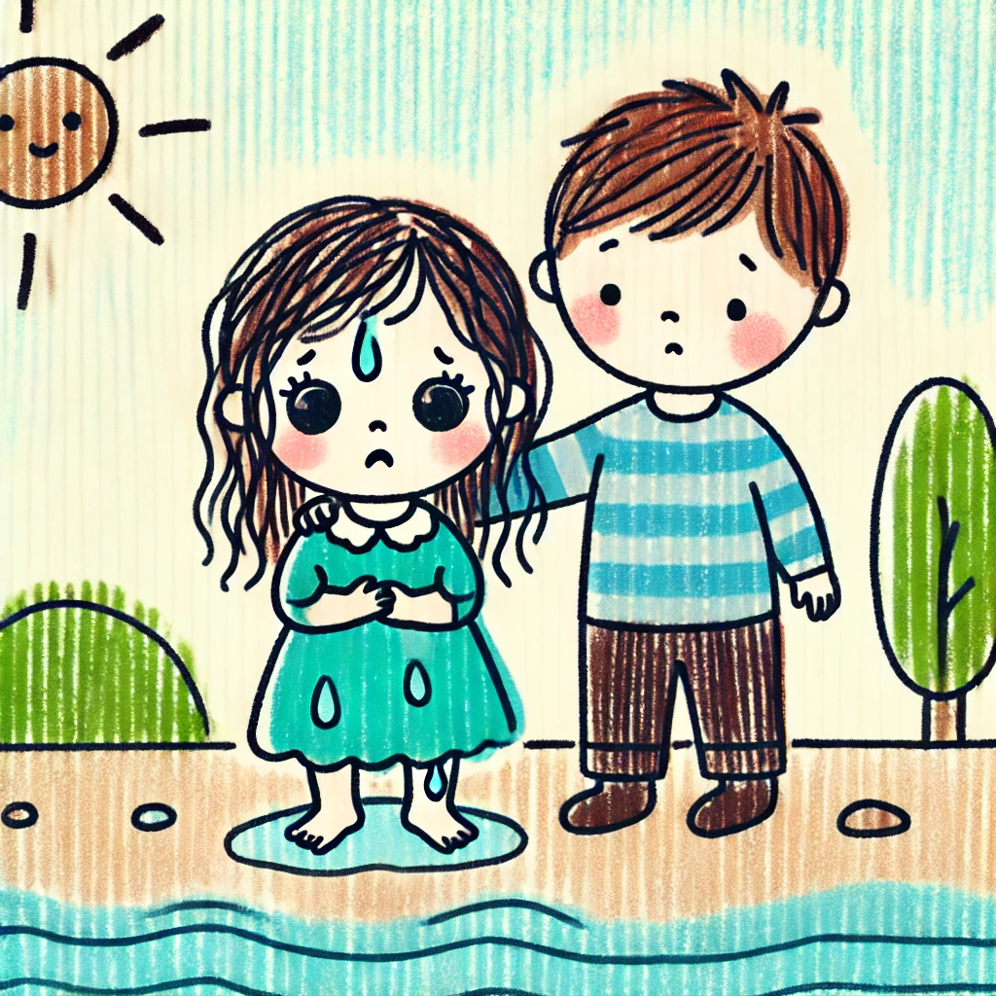
**Date:** June 19, 20XX

Dear Diary,

Today was a little scary. Samuel and I went to the lake again. We were swimming and having fun, but then I went out too far. The water got deep, and I couldn’t touch the bottom. I started to panic, but Samuel swam out and pulled me back to the shallow part. He was so brave! He told me everything was going to be okay, and he held my hand until I felt better. I love my big brother so much.

Love,
Emily

---

#### Diary Entry 4

**Date:** June 25, 20XX

Dear Diary,

Samuel taught me how to fish today. We sat on the dock with our fishing poles, waiting for the fish to bite. I caught a little one, but Samuel caught a big one! We let them go back into the water. Samuel said it’s important to be kind to animals and let them live in their homes. I think Samuel would be a great scientist someday. He knows so much about nature.

Love,
Emily

---

#### Diary Entry 5

**Date:** July 1, 20XX

Dear Diary,

We had a picnic by the lake today. Mom made sandwiches, and we brought cookies and lemonade. Samuel and I played tag and chased butterflies. I told Samuel that when I grow up, I want to be just like him. He laughed and said I could be anything I wanted. I hope we can always have adventures together. Samuel is the best brother in the world.

Love,
Emily

